Ryerson University  
CIND110  
Data Organization for Data Analysts  
Assignment IModeling a Relational Database

**Given below are the details of the** **HealthInsuranceDB database schema**.

|  |  |  |  |  |
| --- | --- | --- | --- | --- |
| Table | **Attribute** | **Data Type** | **Primary Key** | **Foreign Key** |
| **Client** | HealthCardNo First_Name Last_Name Address  Age | CHAR(12) VARCHAR(40) VARCHAR(40) VARCHAR(100)  INT | Yes |  |
| **Agent** | SIN  First_Name  Last_Name  Speciality Experience | CHAR(9)  VARCHAR(40) VARCHAR(40)  VARCHAR(50)  INT | Yes |  |
| **Policy** | Trade_Name Symbol  Fk_HPI_Name | CHAR(100) VARCHAR(50) | Yes | Yes |
| **ProvincialHealthDep** | Name  Address  PhoneNo  Price  Curency | CHAR(100) VARCHAR(100) VARCHAR(15)  INT  INT | Yes  Yes  Yes |  |
| **HealthPolicyIssuers** | Name PhoneNo | CHAR(100) VARCHAR(15) | Yes |  |
| **Contracts** | StartDate  EndDate  Text | DATE  DATE  VARCHAR(512) | Yes  Yes  Yes |  |
| **Recommendations** | Date  Quantity  Fk_Policy_Trade_Name  Fk_Client_HealthCardNo | DATE  CHAR(12) | Yes  Yes | Yes  Yes |
| **ClientAgent** | CL_HealthCardNo IA_SIN | CHAR(12) CHAR(9) | Yes Yes | Yes  Yes |
| **PHDContarct** | PHDName  PHDAddress  PHDPhoneNo  ContStartDate  ContEnd_Date  ContText | CHAR(100)  VARCHAR(100)  VARCHAR(15)  DATE  DATE  VARCHAR(512) | Yes  Yes  Yes  Yes  Yes  Yes | Yes  Yes  Yes  Yes  Yes  Yes |
| **PHDPolicy** | PHDName  PHDAddress  PHDPhoneNo  Trade_Name | CHAR(100)  VARCHAR(100)  VARCHAR(15)  CHAR(100) | Yes  Yes  Yes  Yes | Yes  Yes  Yes  Yes |

**HealthInsuranceDB database schema:**

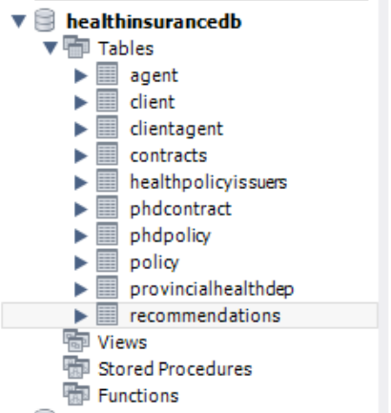

**Note:**

1)- In the contract table, we have 3 attributes namely StartDate, EndDate, Text of the contract., I consider the primary key as the composite of three attributes. In the real scenario, we Should assign longtext datatype to Text of the contract but here because I consider the text of the contract as a part of primary key it raised an error when the datatype was longtext. So I have to change this data type from longtxt to varchar(512) to solve the error.

2)- In the recommendation table, I consider Quantity data type as a ‘Char’ because It should be matched to the Trade_name and ClientHeachCradNo datatype in the foreign key.

In this assignment, I Did both Forward and Reverse engineer. The outputs are attached as the ForwardEngineerHealthInsuranceDB.sql and ReverseEnginnerHealthInsuranceDB.mwb.

The SQL Script after adding 4 records to each table is shown as the following:

**Client Table:**

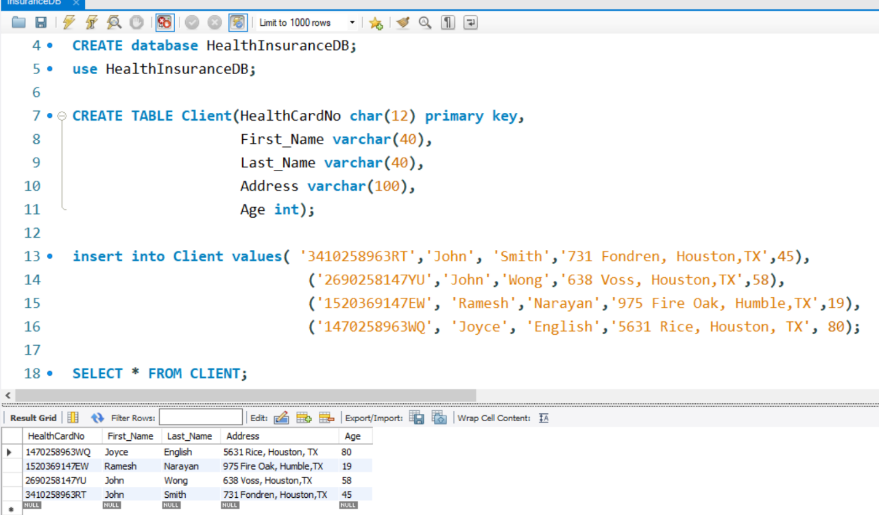

**Agent Table:**

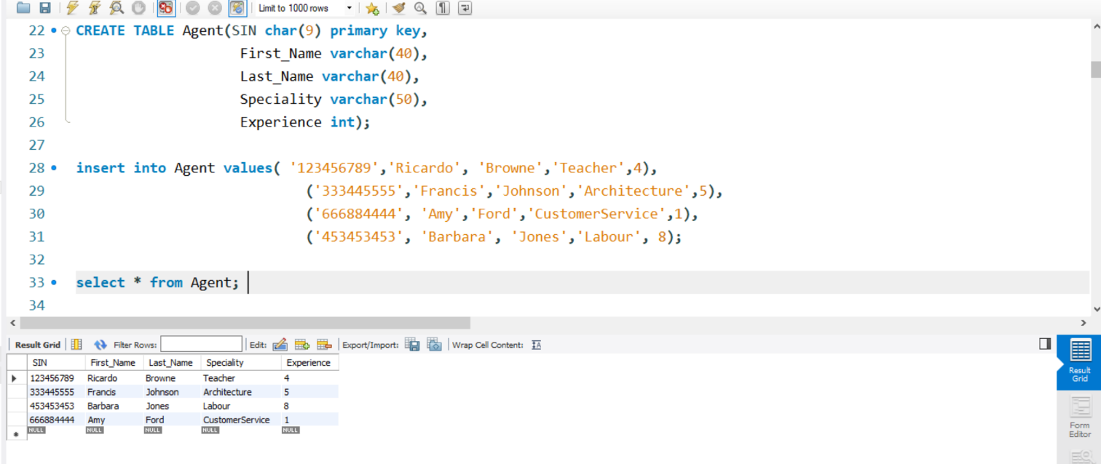

**ClientAgent Table:**

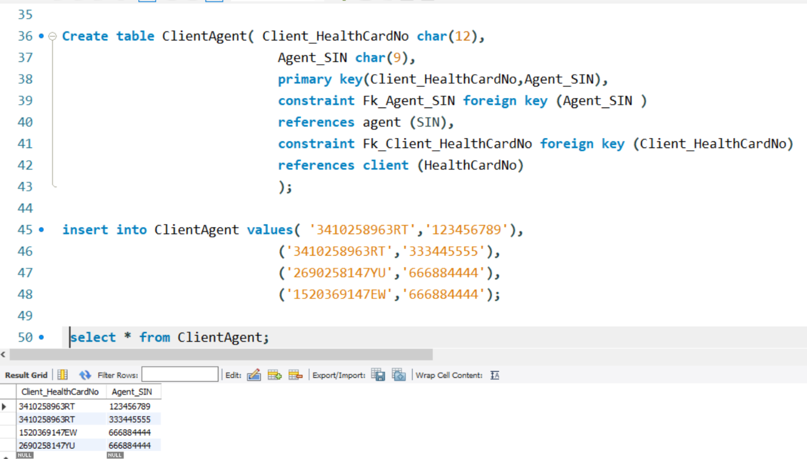

**HealthPolicyIssuers Table:**

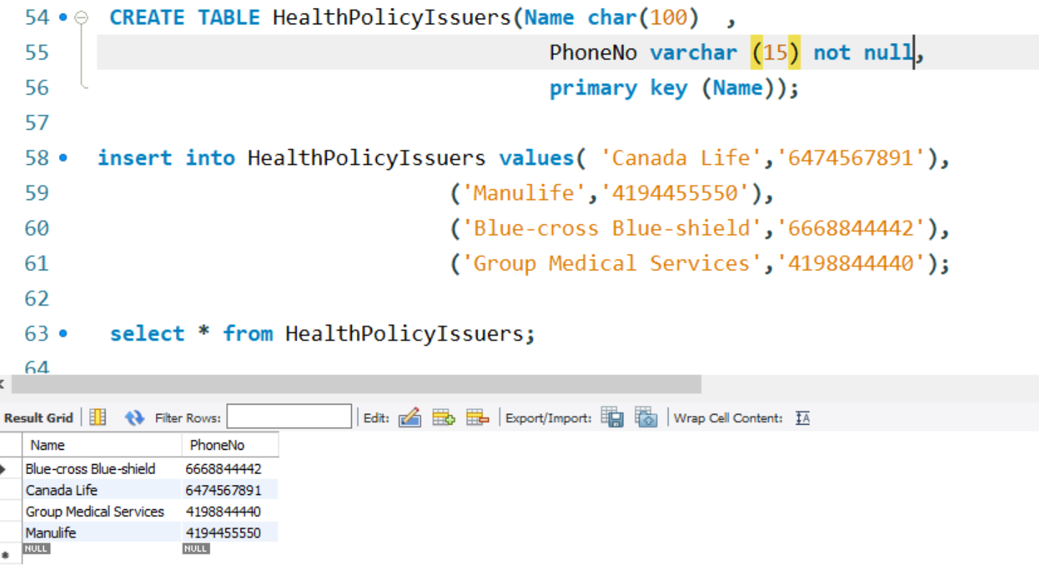

**Policy Table:**

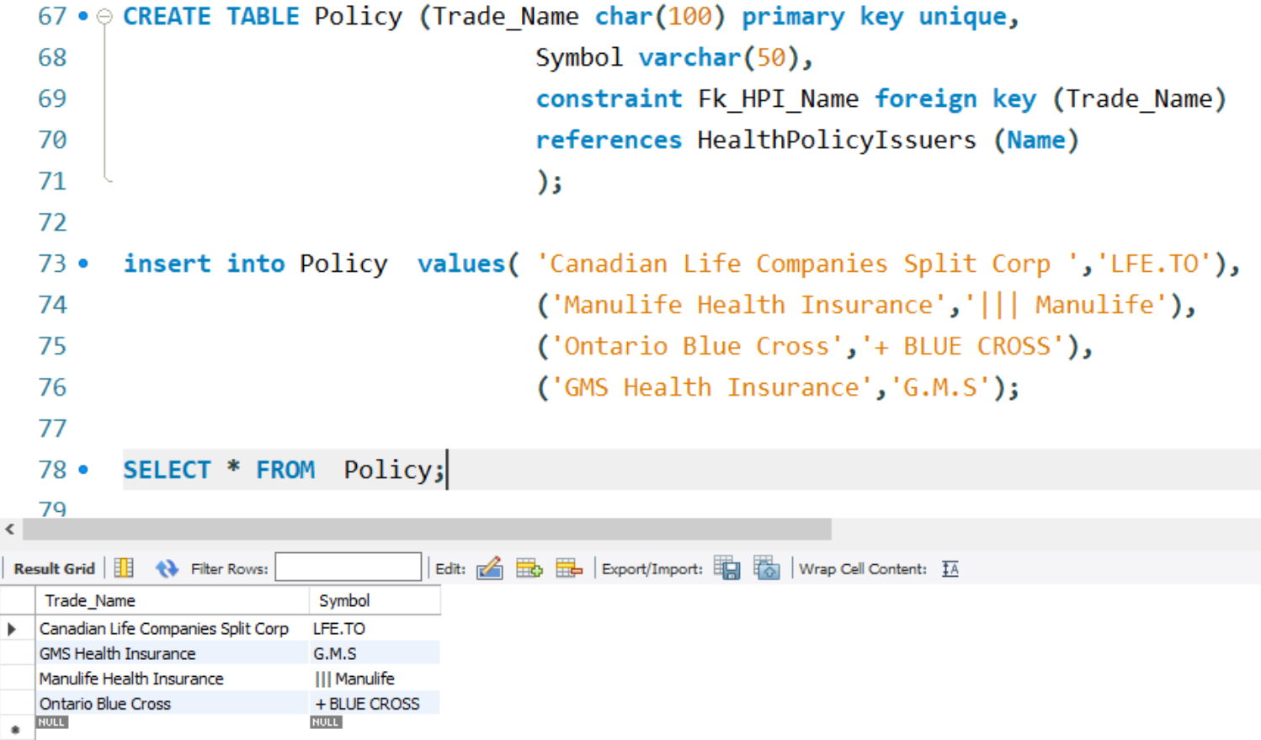

**ProvincialHealthDep** **Table:**

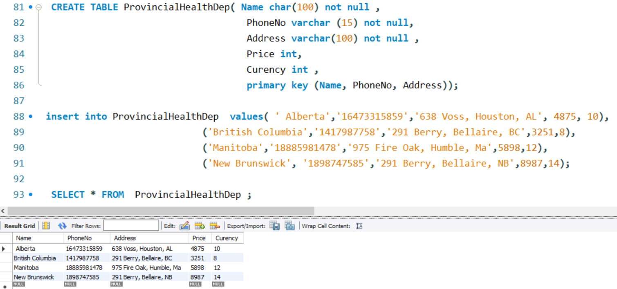

**PHDPolicy Table:**

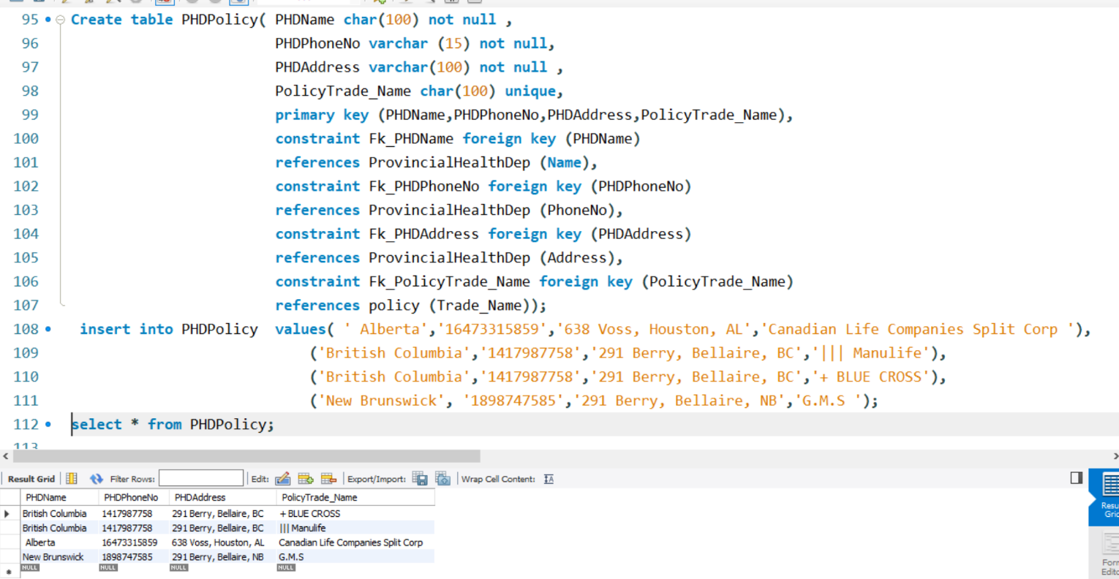

**Contracts Table:**

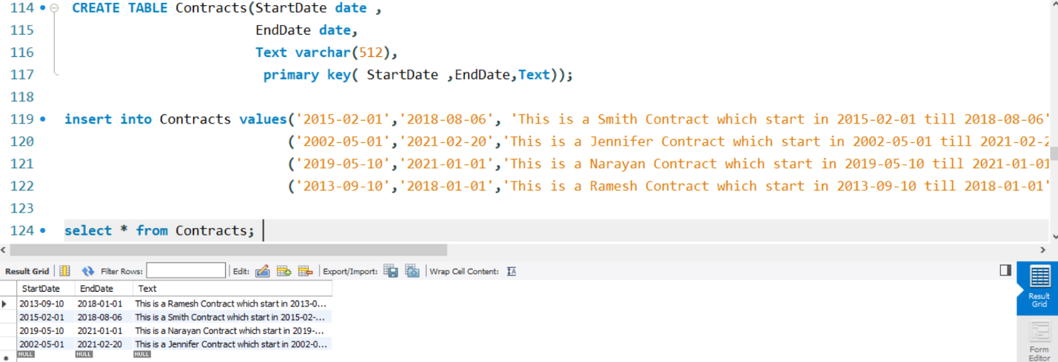

**PHDContract Table:**

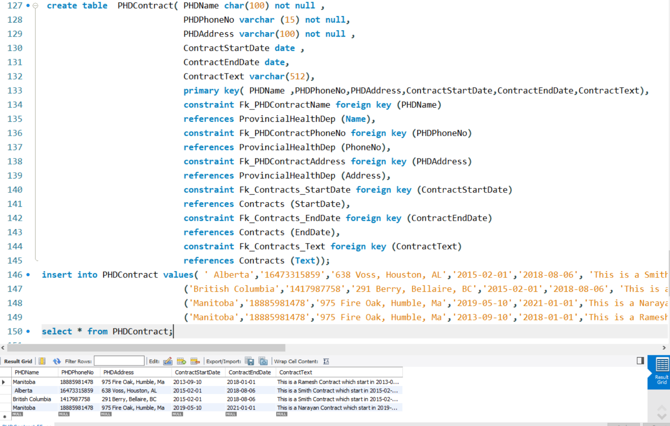

**Recommendations Table:** 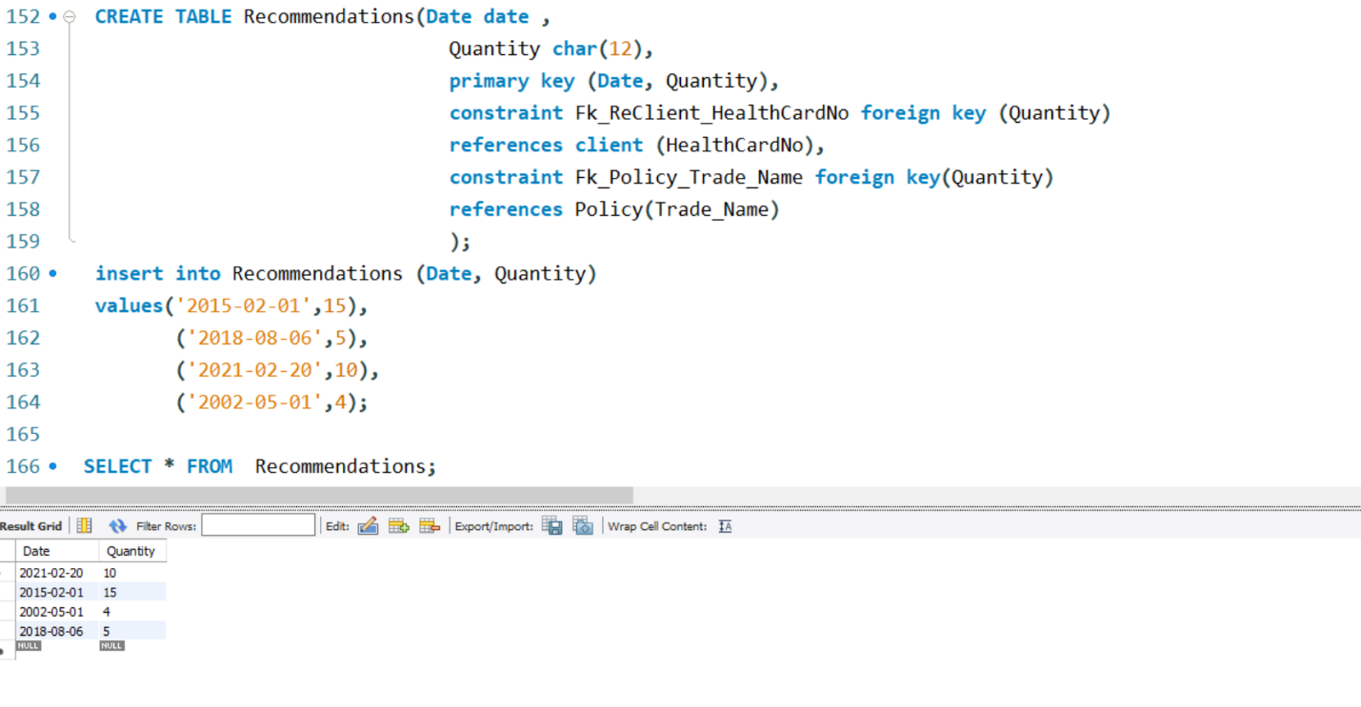

**EER Diagram**

